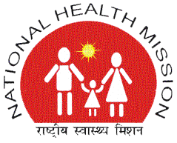 | 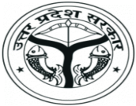
NATIONAL HEALTH MISSION
STATE PROGRAM MANAGEMENT UNIT
19A, VISHAL COMPLEX, VIDHAN SABHA MARG, LUCKNOW- 226001
TELEPHONE -0522-2237595/ Fax -2237390
Email- mdupnrhm@gmail.com

‘TENDER NOTICE’

This is in reference to the tender notice published by NHM, UP on 16-09-2016, Bid Reference No. SPMU/NHM/Procure/FDS/2016-17/21/03), which was available on NHM, UP website since 16-09-2016.
This is to notify that minor modifications to the Revised RFP Document for Free Diagnostic Services have been made and the same has been uploaded on our website: http://www.upnrhm.gov.in. The minor modifications were done on the following clauses:
- Section II: Bidding Data Sheet - 5.5(c);
- Section II: Bidding Data Sheet - 15.1.f - Penalty to Non-Compliance,
  - Criteria No. 4,
  - Criteria No. 5;
- Section V: Activity Schedule - TERMS of REFERENCE - 6. Guidelines for Operating Collection Centre, Clause 12.

The remaining terms and conditions / provisions and other details of the Revised RFP document remain the same, and the updated Revised RFP document has been uploaded on 30/09/2016 on our website http://www.upnrhm.gov.in.

S/d
(Alok Kumar)
Mission Director

