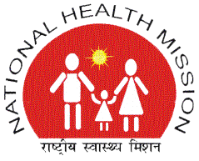 | NATIONAL HEALTH MISSION  STATE PROGRAM MANAGEMENT UNIT  VISHAL COMPLEX, 19-A, VIDHAN SABHA MARG, LUCKNOW- 226001  TELEPHONE -0522-2237595/ Fax -2237390  Email- mdupnrhm@gmail.com | 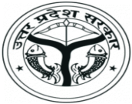

CORRIGENDUM NOTICE

This is in reference to the Tender Notice published by NHM, UP on 19-10-2016 for Bid No. SPMU/NHM/Procure/CT Scan/2016-17/27/01A (CT Scan Service Category 1).The revised RFP for the above, for re-tendering, was published on NHM, UP websitehttp://www.upnrhm.gov.inon 20-10-2016.
A Corrigendum to this RFP has been published on NHM, UP website http://www.upnrhm.gov.in on 22/10/2016. There are no other modifications to the tender beyond what is contained in the Corrigendum, and the remaining provisions of the tender document remain the same.
Any further updates regarding above tender can be accessed on the website: http://www.upnrhm.gov.in.
The decision of National Health Mission- UP shall be final. The SPMU-NHM-U.P. reserves the right to cancel or reject all or any bid(s) without assigning any reason.

S/d
(Alok Kumar)
Mission Director

