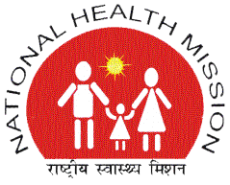 | NATIONAL HEALTH MISSION  STATE PROGRAM MANAGEMENT UNIT  VISHAL COMPLEX, 19-A, VIDHAN SABHA MARG, LUCKNOW- 226001  TELEPHONE -0522-2237595/ Fax -2237390  Email- mdupnrhm@gmail.com, gmiecnrhm@gmail.com | 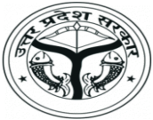

NOTICE

This is in reference to Tender Notice for revised RFP for Hiring of Agency for Research, Evaluation and Documentation of NHM Programmes, published in various National Newspapers on 06.04.17. In this regard it is informed that date of publishing of First Corrigendum (1st Corrigendum) mentioned as 06.01.16, in the published Tender Notice, should be read as 06.01.17. Rest of the information will remain the same.

(Alok Kumar)
Mission Director

