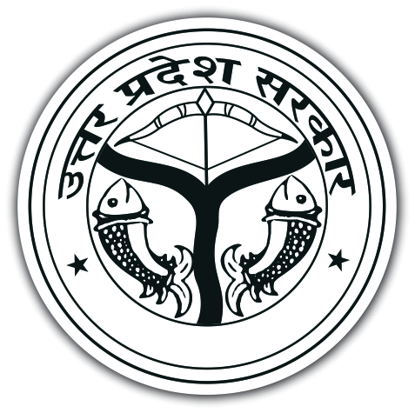 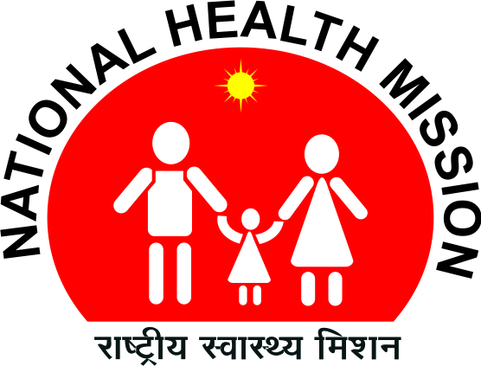

**PRE-CONSULTATION MEETING TO HIRE AGENCY FOR HEALTH FACILITY BRANDING IN UTTAR PRADEESH (UP)**

The Government of India (GOI) has approved funds to implement facility branding in 1286 L2 and L3 level Hospitals across 75 Districts in Uttar Pradesh. National Health Mission (NHM) UP invites eligible agencies to carry out facility branding for Information, education and communication (IEC) dissemination in the whole state of U.P for year 2015-16.

In this regard, a Consultation meeting of probable bidders is proposed to be organized on 21st July 2016 at 3:00 pm at SIFPSA Meeting Hall, Om Kailash Tower, Vidhan Sabha Marg, Lucknow. All probable Bidders are requested to participate.